

**ATAR HUMAN BIOLOGY UNIT 3**

**TASK 4 – Homeostasis Test**

**NAME: _______________________ WEIGHTING: 5%**

**DATE: _______________________ MARK: ___ / 58 = _____ %**

Important Information for Students

1. There are THREE sections in this test - Multiple Choice, Short Answer and Extended Answer.
2. This is a closed-book assessment (no notes are allowed)
3. The time allowed to complete the test is 55 minutes.
4. Write your answers to the Multiple Choice section on the **separate** answer sheet provided. Circle only 1 answer.
5. Write your answers to the Short Answer section in space provided.
6. Write your answers to the Extended Answer section in space provided.

|  |  |  |
| --- | --- | --- |
| **Sections** | **Marks Allocation** | **Your Total** |
| **A - Multiple Choice** | 10 |  |
| **B - Short Answer** | 38 |  |
| **C - Extended Answer** | 10 |  |
| **TOTAL** | 58 |  |

**Multiple choice answer sheet.**

**Use a ball point or ink pen to mark an X** on the letter that represents the best answer from the choice of answers . Marks are not deducted for wrong answers.

1. A B C D 6. A B C D

2. A B C D 7. A B C D

3. A B C D 8. A B C D

4. A B C D 9. A B C D

5. A B C D 10. A B C D

**Multichoice Questions (10 Marks)**

1. Thermo receptors are located in the:
2. skin only.
3. skin and hypothalamus.
4. skin and lungs.
5. hypothalamus only.
6. Hyperventilation is dangerous because:
7. it causes a rapid decrease in blood pH.
8. it causes a decrease in the stimulation of receptors of cardiac centre.
9. it causes an over stimulation of the cardiac centre.
10. it causes a decrease in the stimulation of receptors of the respiratory centre.
11. When the adrenal cortex increases productions of its hormones:
12. less urine is produced.
13. less water is reabsorbed by the nephron and collecting duct.
14. the concentration of urine decreases.
15. less potassium is secreted by the nephron.
16. A researcher recorded the body temperature of seven participants during an investigation into the effects of exercise. The results are shown below.

37.4, 37.9, 36.8, 37.2, 38.0, 37.2, 37.5

Which of the following calculates correctly the mean, median and range for the results?

Mean Median Range

1. 37.5 37.2 1.1
2. 37.4 37.4 1.2
3. 37.2 37.5 1.0
4. 37.4 37.2 1.2
5. Damage to the beta cells of the Islets of Langerhans would cause a decrease in :
6. Adrenaline production.
7. Noradrenaline production.
8. Insulin production.
9. Glucagon production.

6. A person’s brain is injured in an accident resulting in the person unable to regulate temperature, hunger and water balance. Which of the following parts of the person’s brain was affected?

* 1. Hypothalamus
  2. Medulla Oblongata
  3. Cerebellum
  4. Forebrain

7. Glucocorticoids are secreted by the adrenal cortex in response to ACTH from the pituitary gland. Which of the following is not an effect of glucocorticoids?

1. stimulate fat breakdown.
2. produce glucose from amino acids.
3. stimulate the release of insulin.
4. increase blood glucose levels.

8. During a science experiment, a student was required to place his left hand in cold water and his right hand in hot water for a period of 5 minutes. Which of the following would be his body’s response?

1. parasympathetic stimulation of sweat glands in his right hand.
2. vasodilation in blood vessels leading to his left hand and vasoconstriction in blood vessels leading to his right hand.
3. parasympathetic stimulation, causing vasoconstriction in blood vessels leading to his left hand.
4. stimulation of thermoreceptors in the skin of both hands to send nervous impulses to his hypothalamus.

9. Which of the following receptors adapts little or not at all to a stimulus?

1. Touch receptor.
2. Chemoreceptor.
3. Pain receptor.
4. Thermoreceptor.

10. One hour after consuming a glucose drink, the blood glucose concentration of two people was determined. One of these people suffered from Type 1 diabetes. Person A had a blood glucose concentration of 11 mmol/litre and Person B had a blood glucose concentration of 6 mmol/litre. Just before consuming the drink both people had a blood glucose concentration of 5 mmol/litre. The reason for the difference between A and B was that:

1. A was diabetic and therefore was unable to store glucose as glycogen in the liver.
2. B was diabetic and therefore lost excess glucose through the kidneys.
3. A was diabetic and therefore required less glucose in cells for respiration.
4. B was diabetic and therefore was unable to release sufficient glucose from muscle cells.

**Short Answer Section. (38 marks)**

* + - 1. An experiment was carried out with two groups of people. Group A is the control group while Group B has type 1 diabetes. Every 15 minutes, blood samples were taken from all members of both groups and the mean concentrations of insulin, glucagon and glucose were determined. After one hour, each person was given a glucose drink. All results for the **control group** are shown in the graph below. Blood samples were taken every 15 minutes for the next 4 hours.

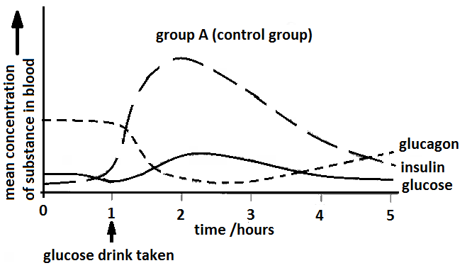

1. Name two hormones, other than insulin and glucagon that are involved in regulating blood glucose concentration. (2 marks)

__________________________________________________________________________________

1. Using the information from the graph above, explain the changes in the blood glucose concentration in group A after drinking the glucose. Refer to the role of insulin and glucagon in regulating blood glucose level in your answer. (6 marks)

__________________________________________________________________________________________________________________________________________________________________________________________________________________________________________________________________________________________________________________________________________________________________________________________________________________________________________________________________________________________________________________________________________________________________________________________________________________________________________________________________________________________________________________________________________________________________________________________________________________________________________________________________________________________________________________________________________________________________________________________________________________________________________________________________________________________________________

1. On the graph given below, sketch lines to show what you would expect the mean concentrations of glucose, insulin and glucagon results of the members of Group B to be.

(3 marks)

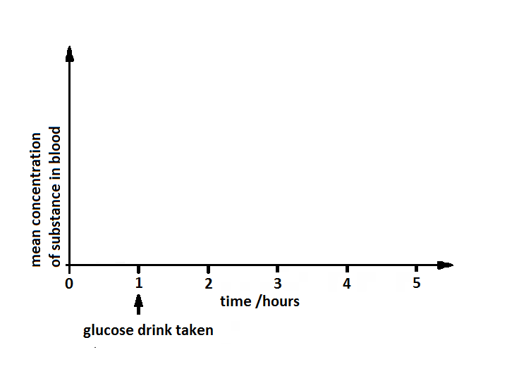

1. A biologist is studying life in Antarctica, where the average daily temperature is -500C. His work requires him to be in the open air making observations for long periods of time.
2. Describe one behavioural modification he would need to make, apart from wearing warmer clothing, when outside observing animals. (1 mark)

________________________________________________________________________________________________________________________________________________________________

b) Explain why this behavioural mechanism will help the biologist maintain his core body temperature.

(3 marks)

________________________________________________________________________________________________________________________________________________________________________________________________________________________________________________________________________________________________________________________________________________________________________________________________________________________________________________________________________________________________________________________________________________________________________________________________________________________________________________________________________

1. Physiological mechanisms controlled by the hypothalamus are also essential for the scientist to maintain his core temperature in these freezing conditions.

Some of these are nervous control and other are controlled by the endocrine system. Complete the table below explaining how these mechanisms operate. (5 marks)

|  |  |  |  |
| --- | --- | --- | --- |
| **Mechanism** | **What happens in freezing conditions?** | **This mechanism is controlled by the hypothalamus and transmitted by** | **How does this help maintain body temperature?** |
| Skin Blood Vessels |  |  | Reduced heat loss |
| Muscles |  | Somatic nervous system |  |
| Metabolic rate | Increased metabolic rate |  | Produces heat |

3. Whilst competing at the Commonwealth games athletes are tested for drugs by the officials but also by coaches to ascertain factors influencing performance. One such test measure blood pH. Athletes are tested before and after events to check for changes. After the 100m freestyle an athletes blood pH went from 7.45 to 7.25.

1. Explain why the blood pH levels changed. (2 marks)

___________________________________________________________________________________________________________________________________________________________________________________________________________________________________________________

1. One swimmer decided that he was not very good at breathing whilst swimming as it slowed him down so, he thought if he hyperventilated before the event and then held his breath during the race he would get a quicker time. Discuss, in terms of breathing, why this would be a dangerous thing for him to do and explain what consequences could occur. (4 marks)

_________________________________________________________________________________________________________________________________________________________________________________________________________________________________________________________________________________________________________________________________________________________________________________________________________________________________________________________________________________________________________________________________________________________________________________________________________________________________________________________________________________________________________________________________________________________

1. The nephron of the kidney plays a key role in maintaining homeostasis of body fluid composition by removing the appropriate levels of water from the body.

a) In the following space draw the feedback loop that would show what your body’s response would be after running 10km in hot conditions and sweating profusely. (6 marks)

**Stimulus**

**Receptor**

**Response**

**Modulator**

**Effector**

b) After a night of drinking alcohol a person may wake in the morning to find they are very dehydrated. Alcohol inhibits the production of ADH.

Explain why the individual would feel dehydrated in the morning after drinking alcohol. (3 marks)

_______________________________________________________________________________________________________________________________________________________________________________________________________________________________________________________________________________________________________________________________________________________________________________________________________________________________________________________________________________________________________________________________________________________________________________________________________________________________________________

1. Explain the roles the skin and the digestive system play in balancing the water and salt balance in the human body. (3 marks)

_______________________________________________________________________________________________________________________________________________________________________________________________________________________________________________________________________________________________________________________________________________________________________________________________________________________________________________________________________________________________________________________________________________________________________________________________________________________________________________

**Extended Answer Question (10 Marks)**

The Pipeline Marathon in Kalgoorlie was scheduled to start in the morning at 7 am. The runs could be a 42 km marathon, a 21km half marathon or 10 km fun run. The expected weather conditions were high of 30oC.

During the event if athlete wants to maintain optimum performance they must maintain homeostasis. Discuss three ways the nervous system is used to maintain the homeostatic balance of the athletes whilst exercising, include reference to the nutrients and internal body environmental conditions. (10 marks)

________________________________________________________________________________________________________________________________________________________________________________________________________________________________________________________________________________________________________________________________________________________________________________________________________________________________________________________________________________________________________________________________________________________________________________________________________________________________________________________________________________________________________________________________________________________________________________________________________________________________________________________________________________________________________________________________________________________________________________________________________________________________________________________________________________________________________________________________________________________________________________________________________________________________________________________________________________________________________________________________________________________________________________________________________________________________________________________________________________________________________________________________________________________________________________________________________________________________________________________________________________________________________________________________________________________________________________________________________________________________________________________________________________________________________________________________________________________________________________________________________________________________________________________________________________________________________________________________________________________________________________________________________________________________________________________________________________________________________________________________________________________________________________________________________________________________________________________________________________________________________________________________________________________________________________________________________________________________________________________________________________________________________________________________________________________________________________________________________________________________________________________